Workgroup C1.067

Planning and progress report – D02

26/05/2025

Tudor Cristian Lacatus Cosma [- ionlac@alum.us.es](mailto:-%20ionlac@alum.us.es)

Table of Contents

INTRODUCTION 4

PLANNING 5

Tasks Performed: 5

Screenshots: 16

Budget: 17

PROGRESS 18

Progress Report: 18

Conflicts 18

Cost Comparison 18

CONCLUSIONS 19

BIBLIOGRAPHY 20

Executive Summary:

The following document addresses the planning and progress of the tasks regarding the individual requirements of Student#2 of the workgroup C1.067 during the time period of the second deliverable of the subject.

Revision Table

|  |  |  |
| --- | --- | --- |
| Revision Number | Date | Description |
| 1.0 | 26/05/2025 | Initial version of the planning and progress report |
|  |  |  |
|  |  |  |

# INTRODUCTION

This report offers a comprehensive overview of the tasks accomplished to fulfill the requirements of the specified deliverable. It features a structured list of tasks that includes titles, descriptions, assignees, and both planned and actual time spent. Key moments in the development process are illustrated with accompanying screenshots, in line with the established working methodology. Furthermore, the report provides a breakdown of estimated and actual budgets, emphasizing personnel and amortization costs. Lastly, it reviews progress records, conflict resolution strategies, and compares initial budget estimates with actual expenditures.

# PLANNING

## Tasks Performed:

**Title:** Task 152/T1 - Produce a UML domain model regarding the information requirements.

**Description:** Check that the UML is well-defined.

**Assignee/s:** Javier Arellano López (javiarellanoo in GitHub)

**Role/s:** Tester

**Expected Time:** 0.75 H

**Time Spent:** 0.25 H

**Title:** Task 152 - Produce a UML domain model regarding the information requirements.

**Description:** Produce a UML domain model regarding the information requirements of student #2.

**Assignee/s:** Tudor Cristian Lacatus Cosma (tcosma in GitHub)

**Role/s:** Developer

**Expected Time:** 1.5 H

**Time Spent:** 1 H

**Title:** Task 72/T1 - Create recommendations entity (Student#2)

**Description:** Review that the initial population works fine, and the recommendations data is well-displayed

**Assignee/s:** Aarón Jesús Acuña Bellido (aaronacuuna in GitHub)

**Role/s:** Tester

**Expected Time:** 0.5 H

**Time Spent:** 0.25 H

**Title:** Task 084/T1 - Implement Customers dashboards (Student#2)

**Description:** Review that the dashboard is correctly implemented

**Assignee/s:** Raul Calero Capote (RauruGW in GitHub)

**Role/s:** Tester

**Expected Time:** 1 H

**Time Spent:** 0.5 H

**Title:** Task 073/T2 - Create sample test data for booking (Student#2)

**Description:** Check that the sample data is consistent.

**Assignee/s:** Miguel Prado Jiménez (mpradoj04 in GitHub)

**Role/s:** Tester

**Expected Time:** 0.5 H

**Time Spent:** 0.25 H

**Title:** Task 073/R1 - Create sample test data for booking (Student#2)

**Description:** Update the sample data so is more consistent

**Assignee/s:** Tudor Cristian Lacatus Cosma (tcosma in GitHub)

**Role/s:** Developer

**Expected Time:** 1 H

**Time Spent:** 1.25 H

**Title:** Task 066/T2 - Create the sample test data for passenger(Student#2)

**Description:** Check that the sample data is consistent

**Assignee/s:** Raul Calero Capote (RauruGW in GitHub)

**Role/s:** Tester

**Expected Time:** 0.25 H

**Time Spent:** 0.25 H

**Title:** Task 066/R1 - Create the sample test data for passenger(Student#2)

**Description:** Change sample data so it's consistent

**Assignee/s:** Tudor Cristian Lacatus Cosma (tcosma in GitHub)

**Role/s:** Developer

**Expected Time:** 1 H

**Time Spent:** 1.5 H

**Title:** Task 064/T3 - Create customer entity (Student#2)

**Description:** Check that the validator ensures the uniqueness

**Assignee/s:** Aarón Jesús Acuña Bellido (aaronacuuna in GitHub)

**Role/s:** Tester

**Expected Time:** 0.5 H

**Time Spent:** 0.75 H

**Title:** Task 064/R2 - Create customer entity (Student#2)

**Description:** Change the validator to ensure the uniqueness of the entity

**Assignee/s:** Tudor Cristian Lacatus Cosma (tcosma in GitHub)

**Role/s:** Developer

**Expected Time:** 1 H

**Time Spent:** 1.25 H

**Title:** Task 065/R2 - Create booking entity (Student#2)

**Description:** Change the validator to ensure the uniqueness of the entity

**Assignee/s:** Tudor Cristian Lacatus Cosma (tcosma in GitHub)

**Role/s:** Developer

**Expected Time:** 1 H

**Time Spent:** 0.5 H

**Title:** Task 065/T3 - Create booking entity (Student#2)

**Description:** Check that the validator ensures the uniqueness

**Assignee/s:** Javier Arellano López (javiarellanoo in GitHub)

**Role/s:** Tester

**Expected Time:** 0.25 H

**Time Spent:** 0.75 H

**Title:** Task 065/T2 - Create booking entity (Student#2)

**Description:** Review that the locator code of the booking is validated to be unique.

**Assignee/s:** Aarón Jesús Acuña Bellido (aaronacuuna in GitHub)

**Role/s:** Tester

**Expected Time:** 0.5 H

**Time Spent:** 0.5 H

**Title:** Task 065/R1 - Create booking entity (Student#2)

**Description:** Create a validator to valid that the locator code of a booking is unique.

**Assignee/s:** Tudor Cristian Lacatus Cosma (tcosma in GitHub)

**Role/s:** Developer

**Expected Time:** 0.5 H

**Time Spent:** 2 H

**Title:** Task 064/T2 - Create customer entity (Student#2)

**Description:** Review that the customer entity validator validates that the identifier is unique.

**Assignee/s:** Javier Arellano López (javiarellanoo in GitHub)

**Role/s:** Tester

**Expected Time:** 0.23 H

**Time Spent:** 0.25 H

**Title:** Task 064/R1 - Create customer entity (Student#2)

**Description:** Ensure that the identifier of a customer is unique.

**Assignee/s:** Tudor Cristian Lacatus Cosma (tcosma in GitHub)

**Role/s:** Developer

**Expected Time:** 1 H

**Time Spent:** 1 H

**Title:** Task 074/T1 - Create sample test data for passenger (Student#2)

**Description:** Test that sample data is correct

**Assignee/s:** Aarón Jesús Acuña Bellido (aaronacuuna in GitHub)

**Role/s:** Tester

**Expected Time:** 0.25 H

**Time Spent:** 0.5 H

**Title:** Task 073/T1 - Create sample test data for booking (Student#2)

**Description:** Review sample data and its consistency

**Assignee/s:** Raul Calero Capote (RauruGW in GitHub)

**Role/s:** Tester

**Expected Time:** 0.5 H

**Time Spent:** 0.5 H

**Title:** Task 068/T3 - Create sample test data for customer (Student#2)

**Description:** Verify the sample data is correct and that everything works properly

**Assignee/s:** Javier Arellano López (javiarellanoo in GitHub)

**Role/s:** Tester

**Expected Time:** 1 H

**Time Spent:** 0.25 H

**Title:** Task 068/R2 - Create the sample test data for customer (Student#2)

**Description:** Review of the sample data in order to follow the base customer

**Assignee/s:** Tudor Cristian Lacatus Cosma (tcosma in GitHub)

**Role/s:** Developer

**Expected Time:** 1 H

**Time Spent:** 1.5 H

**Title:** Task 068/T2 - Create the sample test data for customer (Student#2)

**Description:** Review that the new sample data is cohorent and consistent

**Assignee/s:** Javier Arellano López (javiarellanoo in GitHub)

**Role/s:** Tester

**Expected Time:** 0.25 H

**Time Spent:** 0.25 H

**Title:** Task 068/R1 - Create the sample test data for customer (Student#2)

**Description:** Review of the sample data in order to follow the base customer

**Assignee/s:** Tudor Cristian Lacatus Cosma (tcosma in GitHub)

**Role/s:** Developer

**Expected Time:** 1 H

**Time Spent:** 2 H

**Title:** Task 074 - Create sample test data for passenger (Student#2)

**Description:** Create valid sample data for passenger entity

**Assignee/s:** Tudor Cristian Lacatus Cosma (tcosma in GitHub)

**Role/s:** Developer

**Expected Time:** 1 H

**Time Spent:** 3 H

**Title:** Task 073 - Create sample test data for booking (Student#2)

**Description:** Create sample data for the booking entity

**Assignee/s:** Tudor Cristian Lacatus Cosma (tcosma in GitHub)

**Role/s:** Developer

**Expected Time:** 1 H

**Time Spent:** 2 H

**Title:** Task 72 - Create recommendations entity (Student#2)

**Description:** The system must include a board to recommend something in the city and/or country of a given airport. Recommendations can be about experiences, activities, restaurants, accommodation or any other thing that a person may find interesting at the destina-tion. A web service must be used to populate this entity with information about rec-ommendations. Thus, the exact data to store depends on the chosen service, and it is the students' responsibility to define them accordingly. It is also the students’ respon-sibility to find the appropriate service; no implicit or explicit liabilities shall be covered by the University of Seville or their individual affiliates if the students contract pay-per-use services! The students are strongly advised to ensure that the service they choose is free of charge.

**Assignee/s:** Tudor Cristian Lacatus Cosma (tcosma in GitHub)

**Role/s:** Developer

**Expected Time:** 0.5 H

**Time Spent:** 1.5 H

**Title:** Task 071/T1 - Upload the link to the project dashboard (Student#2)

**Description:** Check that the link provided to the dashboard of Student#2 correctly reflects all of the related tasks for his individual requirements and the file is under the correct folder.

**Assignee/s:** Aarón Jesús Acuña Bellido (aaronacuuna in GitHub)

**Role/s:** Tester

**Expected Time:** 0.25 H

**Time Spent:** 0.05 H

**Title:** Task 071 - Upload the link to the project dashboard (Student#2)

**Description:** Create a document and add the link to the project dashboard related to Student#2's individual tasks. Add said document in the reports/Deliverable 2/Student#2 folder.

**Assignee/s:** Tudor Cristian Lacatus Cosma (tcosma in GitHub)

**Role/s:** Developer

**Expected Time:** 0.05 H

**Time Spent:** 0.05 H

**Title:** Task 068/T1 - Create sample test data for customer (Student#2)

**Description:** Verify the sample data is correct and that everything works properly

**Assignee/s:** Javier Arellano López (javiarellanoo in GitHub)

**Role/s:** Tester

**Expected Time:** 0.5 H

**Time Spent:** 0.15 H

**Title:** Task 068 - Create sample test data for customer (Student#2)

**Description:** Produce assorted sample data to test your application informally. The data must in-clude two customer accounts with credentials “customer1/customer1” and “custom-er2/customer2”. Create an additional customer account with credentials “customer3/ customer3” that represents a customer with only profile data.

**Assignee/s:** Tudor Cristian Lacatus Cosma (tcosma in GitHub)

**Role/s:** Developer

**Expected Time:** 0.8 H

**Time Spent:** 0.5 H

**Title:** Task 066/T1 - Create passenger entity (Student#2)

**Description:** Please check that:  
  
The entity is correctly generated, that is, the table is created in the DB and the project compiles  
Each attribute has at most 3 annotations  
The entity meets the requirements stated by the client, and in case of ambiguities, it follows the instructions given by the lecturer in the forum of the subject.  
In case of custom validation, please check that it is correctly instanciated  
In case of the presence of relations with other attributes, please check that the indications given by the lecturers are followed.

**Assignee/s:** Miguel Prado Jiménez (mpradoj04 in GitHub)

**Role/s:** Tester

**Expected Time:** 0.5 H

**Time Spent:** 0.1 H

**Title:** Task 065/T1 - Create booking entity (Student#2)

**Description:** Please check that:  
  
The entity is correctly generated, that is, the table is created in the DB and the project compiles  
Each attribute has at most 3 annotations  
The entity meets the requirements stated by the client, and in case of ambiguities, it follows the instructions given by the lecturer in the forum of the subject.  
In case of custom validation, please check that it is correctly instanciated  
In case of the presence of relations with other attributes, please check that the indications given by the lecturers are followed.

**Assignee/s:** Javier Arellano López (javiarellanoo in GitHub)

**Role/s:** Tester

**Expected Time:** 0.5 H

**Time Spent:** 0.25 H

**Title:** Task 064/T1 - Create customer entity (Student#2)

**Description:** Please check that:  
  
The entity is correctly generated, that is, the table is created in the DB and the project compiles  
Each attribute has at most 3 annotations  
The entity meets the requirements stated by the client, and in case of ambiguities, it follows the instructions given by the lecturer in the forum of the subject.  
In case of custom validation, please check that it is correctly instanciated  
In case of the presence of relations with other attributes, please check that the indications given by the lecturers are followed.

**Assignee/s:** Raul Calero Capote (RauruGW in GitHub)

**Role/s:** Tester

**Expected Time:** 0.25 H

**Time Spent:** 0.1 H

**Title:** Task 066 - Create passenger entity (Student#2)

**Description:** 5) A passenger is an individual who takes a flight and he or she must be registered in the corresponding booking. The system must store the following data about passengers: a full name (shorter than 256 characters), an email, a passport number (pattern “^[A-Z0-9]{6,9}$”), a date of birth, and, optionally, his or her special needs (shorter than 51 characters).

**Assignee/s:** Tudor Cristian Lacatus Cosma (tcosma in GitHub)

**Role/s:** Developer

**Expected Time:** 1 H

**Time Spent:** 2 H

**Title:** Task 065 - Create booking entity (Student#2)

**Description:** A booking is a reservation made by a customer to purchase a flight, guaranteeing some seats on a specific itinerary and associating some passengers' details with the trip. The system must manage the following information for each booking: a locator code (unique, pattern "^[A-Z0-9]{6,8}$"), a purchase moment (in the past), a travel class ("ECONOMY", BUSINESS"), and a price. Optionally, the system should record the last nibble of the credit card used for payment.

**Assignee/s:** Tudor Cristian Lacatus Cosma (tcosma in GitHub)

**Role/s:** Developer

**Expected Time:** 1 H

**Time Spent:** 1.25 H

**Title:** Task 064 - Create customer entity (Student#2)

**Description:** Customers are the people who purchase flights. The system must store the following data about them: an identifier (unique, pattern "^[A-Z]{2-3}\d{6}$", where the first two or three letters correspond to their initials), a phone number (pattern "^\+?\d{6,15}$"), a physical address (up to 255 characters), plus a city and a country (both up to 50 characters). Optionally, customers may have some earned points (up to 500k points).

**Assignee/s:** Tudor Cristian Lacatus Cosma (tcosma in GitHub)

**Role/s:** Developer

**Expected Time:** 1 H

**Time Spent:** 0.5 H

**Title:** Planning and progress report

**Description:** Write a planning and progress report

**Assignee/s:** Tudor Cristian Lacatus Cosma (tcosma in GitHub)

**Role/s:** Proyect Manager

**Expected Time:** 0,5 H

**Time Spent:** 1 H

**Title:** Analysis report

**Description:** Write an analysis report

**Assignee/s:** Tudor Cristian Lacatus Cosma (tcosma in GitHub)

**Role/s:** Analyst

**Expected Time:** 0,5 H

**Time Spent:** 1 H

## Screenshots:

The following screenshots were taken during different moments of the Deliverable, showcasing different stages of the methodology proposed by the subject.

**Tasks in the middle of the process:**

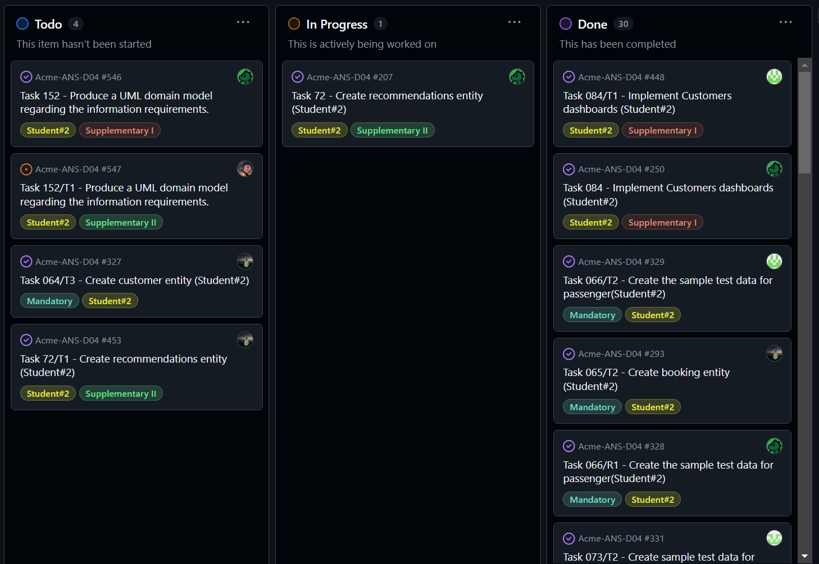

**Tasks in the done lane:**

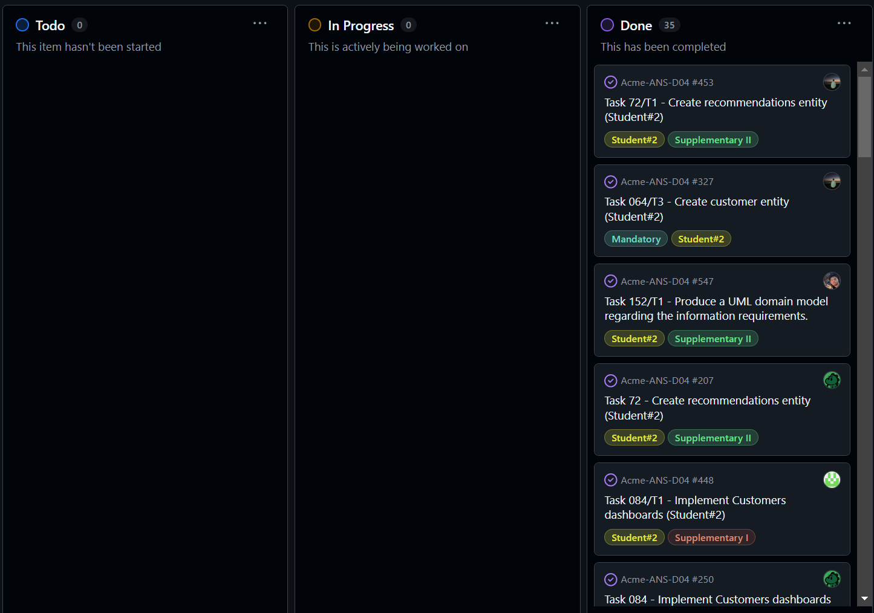

## Budget:

The budget for Delivery 02 includes the estimated hours per role, personnel costs, and amortization costs. Depending on the nature of the task, I have assumed a specific role, which is considered when calculating the budget. Personnel costs are determined based on the following hourly rates:

* Project Managers and analysts: €30.00 per hour
* Developers, testers, and other roles: €20.00 per hour

After summing the estimated times for each task, taking into account the assumed role, the final budget is obtained.

|  |  |  |  |
| --- | --- | --- | --- |
| Role | Hourly Rate (€) | Estimated time(hrs) | Estimated cost (€) |
| Project Manager | 30 | 0,5 | 15 |
| Analyst | 30 | 0,5 | 5 |
| Developer | 20 | 15,35 | 307 |
| Tester | 20 | 8,48 | 169,6 |
| Totals: |  | 24,83 | 496,6 |

The project requires the use of a laptop or a personal computer, valued at 1150€, which is amortized over three years (36 months, 4 weeks per month). Hence, the weekly amortization cost is the following:

Amortization cost per week = 1150/(36*4) = 7,98€

Since the second delivery has had a length of 3 weeks, we compute the amortization cost of this time period and add it to the final amount.

Thus, the cost is of 520,55€

# PROGRESS

## Progress Report:

This letter outlines my performance in individual tasks, evaluated against the performance indicators detailed in the Charter Report. It also details the corresponding actions I've taken.

Regarding the "Actual Grade vs Expected Grade" indicator, I aimed for the highest possible grade. As a member of group C1.067, I attended all lectures and follow-up sessions, completed all assigned tasks within the original deadlines, and performed as stipulated in the Charter Report.

## Conflicts

No conflicts have occurred during this time period.

## Cost Comparison

After completing the delivery, I will compare the estimated costs with the actual costs incurred. This includes the number of hours spent per role, personnel costs, amortization and the total cost difference.

|  |  |  |  |
| --- | --- | --- | --- |
| Role | Hourly Rate (€) | Real time(hrs) | Real cost (€) |
| Project Manager | 30 | 1 | 30 |
| Analyst | 30 | 1 | 30 |
| Developer | 20 | 22,8 | 456 |
| Tester | 20 | 6 | 120 |
| Totals: |  | 30.8 | 636 |

The project requires the use of a laptop or a personal computer, valued at 1150€, which is amortized over three years (36 months, 4 weeks per month). Hence, the weekly amortization cost is the following:

Amortization cost per week = 1150/(36*4) = 7,98€

Since the second delivery has had a length of 3 weeks, we compute the amortization cost of this time period and add it to the final amount.

Thus, the cost is of 659,95€.

Taking a quick comparison to both costs, we see that we have obtained a lose of 139,39€. This indicates a wrong estimation effort.

# CONCLUSIONS

# In summary, this report has detailed the planning and execution of this delivery, encompassing task allocation, quality assurance measures, feedback sessions, and the guidance received in meetings. These elements have been crucial for the project's progress and success. However, the cost comparison has revealed a significant deviation of €139.39 from the estimated budget. This difference highlights the need to adjust future estimations to improve accuracy and efficiency in resource management.

# BIBLIOGRAPHY

Intentionally blank